EART33001 – Practical SEM and EPMA

Part 1. Below is a table of characteristic emission energies for selected elements.

Using the periodic table available in the practical folder on Canvas (“PeriodicTable_XrayLines”), list the energies for the K_{α}, K_{β} and L_{α} X-ray emission lines.

Elements | K_{α} (keV) | K_{β} (keV) | L_{α} (keV)
O | 0.53
Al | 1.49 | 1.55
Si | 1.74 | 1.83
Mg | 1.25 | 1.30
Ca | 3.69 | 4.01 | 0.34
Cr | 5.41 | 5.95 | 0.57
Fe | 6.40 | 7.06 | 0.70
Rb | 13.39 | 14.96 | 1.69

The EDS spectrum below is from a mineral in a granite, which contains the elements listed in the table above. Identify the peaks labelled 1 to 9 in this EDS spectrum.

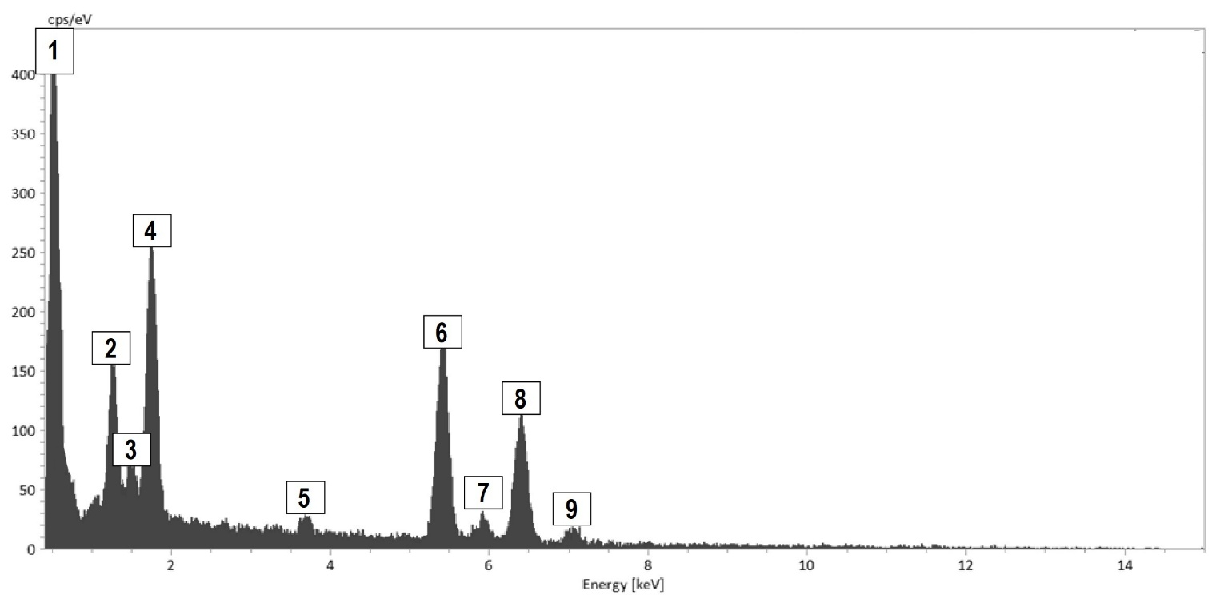

1. O Ka +/- Cr La; 2. Mg K; 3. Al K; 4. Si K + Rb La; 5. Ca Ka; 6. Cr Ka; 7. Cr Kb; 8. Fe Ka; 9. Fe Kb

Part 2 - SEM. Familiarise yourselves with using SEM using the virtual SEM at https://myscope.training/SEM_simulator.html

The virtual instrument, like a real SEM, has a Vent and an Evacuate button in order to introduce the sample. Why must the scanning electron microscope operate under vacuum?

A good vacuum in the primary column ensures that as many electrons as possible can travel freely throughout the column, without interacting with any air atoms/molecules, and reach the sample in the specimen chamber.

Vent the instrument, open the sample chamber, insert sample, close, and evacuate.
Set the working distance to 10 mm. Select the rock sample. Select 15 kV accelerating voltage, and press HT, which starts the beam in the SEM simulator.

Choose a 10 nm spot size, adjust brightness and contrast, adjust coarse focus to try and get a sharp image. Move to slow scan 1 and refine sharpness using fine focus and stigmator controls.

Try increasing accelerating voltage to 20 kV, then 30 kV.
What happens when you increase the accelerating voltage? Why?

The main thing that happens when increasing accelerating voltage is increasing the size of interaction on the sample. As a result, more electrons are emitted, inducing an increased brightness. However, an increased interaction volume also means a slightly degraded spatial resolution, as information from sample is extracted from larger volume.

What happens when you change the working distance to 20 mm?
And when you change it to 0 mm? Why?

Changing the working distance between sample and BSE detector changes focal point position.
Changing working distance to 0 mm effectively means crashing the sample into the BSE detector, which is a costly mistake to make!

Try to get the sharpest BSE image possible by adjusting the brightness and contrast, and playing with the focus and astigmatism knobs. Note that you can increase magnification to adjust more precisely the focus.

Once you are happy with your settings, save a BSE image of the sample.

This rock contains albite (average Z = 10.7), orthoclase (average Z = 11.9), pyrite (average Z = 20.7) and galena (average Z = 73.2).

Label your image with these different mineral phases.

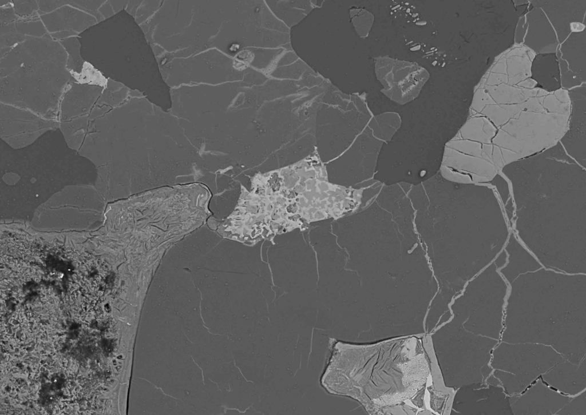
orthoclase
albite
pyrite
galena

Let’s move onto the virtual EDS simulator at https://myscope.training/EDS_simulator.html

The sample here is from an igneous rock made up of predominantly of silicate minerals, with accessory oxide and sulphide minerals. A backscattered compositional image has been acquired as the first step in the mapping process.

Select the ‘Area’ mode.
The software measures intensities of X-ray emitted between 0 and 15 keV using energy dispersive spectroscopy (EDS).

Press ‘Label’ so that the peaks are labelled according to what elements they correspond to.
Why are there 2 peaks labelled for Ti and Fe?
Why is there only one peak labelled for Na, Mg, or Al for example? (the “emission_lines.pdf” document may be helpful here).

Two peaks are visible for Fe and Ti (and Ca) because the energy dispersive spectrometer (EDS) energy resolution is good enough to separate the Kα and Kβ characteristic X-rays. On the other hand, the resolution is not sufficient for separating these two X-ray lines for lighter elements such as Na, Mg and Al – Kα and Kβ characteristic X-rays appear as a single peak.

The software then acquires X-ray maps of the area of interest for selected elements.

The sample contains the following mineral phases – using the X-ray maps and the mineral chemistry, label the back-scattered electron image below.

Apatite Ap Ca₅(PO₄)₃(F,Cl,OH)
Ilmenite Ilm FeTiO₃
Andesine And (Ca,Na)(Al,Si)₄O₈
Diopside Dio CaMgSi₂O₆
Pyrite Py FeS₂
Magnetite Mag Fe₃O₄

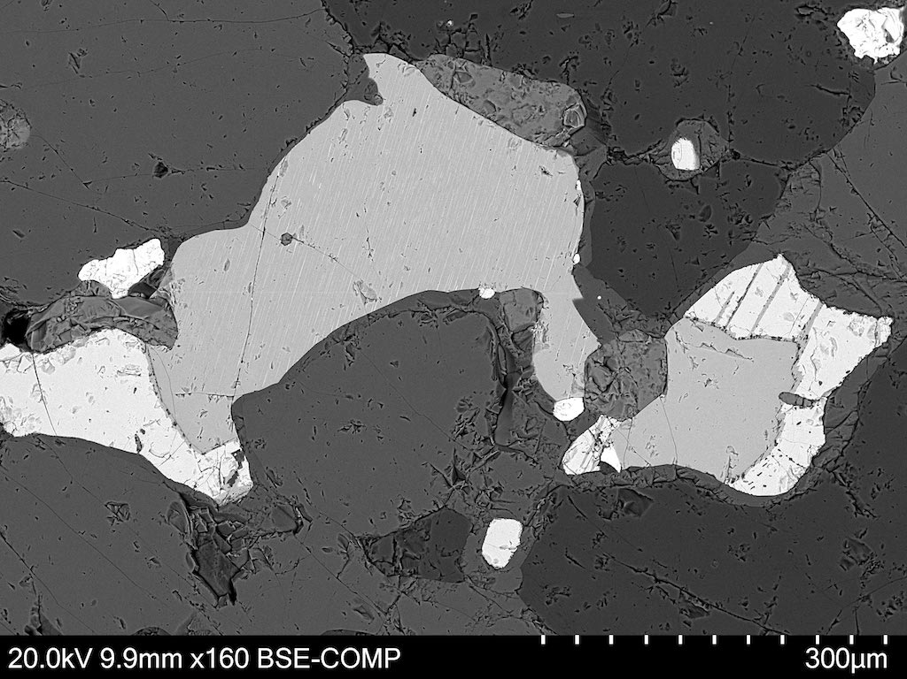
Py
Py
Py
Mag
Mag
Dio
Dio
Dio
And
And
Ilm
Ilm
Ap
Ap

Restart the virtual EDS simulator at https://myscope.training/EDS_simulator.html and select the ‘Point’ mode. You can now acquire X-ray EDS spectra for the different mineral phases, and obtain a semi-quantitative geochemical analysis.

Part 3 – EPMA. You are using wavelength dispersive spectroscopy (WDS) on the electron microprobe (EPMA) to measure precisely the chemical composition of minerals in your samples. Your EPMA instrument is equipped with LIF, PET, and TAP crystals.

You want to detect Fe Kα X-rays diffracted from a LiF analyser crystal with 2.013 Å d-spacing, at what angle θ should you rotate the crystal to?

Remember: c = 3 x 10⁸ m s⁻¹, h = 6.6262 x 10^{–34} J s, 1 eV = 1.6022 x 10⁻¹⁹ J, c = λ.ν and E = hν

Use Bragg equation, nλ = 2d sin θ, and assume n=1.
Fe Kα X-rays are 6.40 keV. Need to convert this to wavelength λ
→ 1 ev = 1.6022 × 10⁻¹⁹ J, so 6.40 eV = 1.0254 × 10⁻¹⁵ J.
We know that E = hc / λ, so λ = hc / E.
→ λ = (6.626×10⁻³⁴ . 3×10⁸) / 1.0254×10⁻¹⁵ = 1.939×10⁻¹⁰ m = 1.939 Å.
sin θ = nλ / 2d = (1×1.939 Å) / (2×2.013 Å) → sin⁻¹ (1×1.939 Å) / (2×2.013 Å) = 28.8º

In December 2020, the Chang’e-5 space mission returned the first samples from the Moon since 1976. Since their return to Earth, scientists have been analysing these samples.

The table below reports electron microprobe analyses of plagioclase and olivine (also provided in the Excel spreadsheet called “EPMA_Dataset_2026_Blank.xlsx” on Canvas).

Plagioclase composition ranges between the two end-members Anorthite (An) CaAl₂Si₂O₈ and Albite (Ab) NaAlSi₃O₈. Olivine composition ranges between the two end-members Forsterite (Fo) Mg₂SiO₄ and Fayalite (Fa) Fe₂SiO₄.

Analysis | SiO₂ | TiO₂ | Al₂O₃ | FeO | MnO | MgO | CaO | Na₂O | K₂O | Cr₂O₃ | P₂O₅ | Total
B2-3 | 50.89 | 0.06 | 30.77 | 1.03 | 0.05 | 0.13 | 14.80 | 2.30 | 0.23 | 0.00 | 0.04
B2-4 | 45.38 | 0.05 | 32.85 | 0.28 | 0.00 | 0.11 | 18.09 | 0.57 | 0.04 | 0.00 | 0.02
B2-17 | 51.66 | 0.20 | 29.99 | 1.19 | 0.00 | 0.02 | 13.93 | 2.10 | 0.73 | 0.00 | 0.03
B2-20 | 49.96 | 0.06 | 31.05 | 1.19 | 0.00 | 0.05 | 15.28 | 1.24 | 0.27 | 0.01 | 0.00
B2-21 | 50.31 | 0.06 | 31.01 | 3.14 | 0.01 | 0.06 | 15.44 | 1.94 | 0.26 | 0.01 | 0.04
B2-22 | 49.89 | 0.04 | 31.23 | 0.93 | 0.03 | 0.07 | 15.27 | 1.37 | 0.21 | 0.02 | 0.05
B2-27 | 49.42 | 0.08 | 31.48 | 0.84 | 0.02 | 0.12 | 15.64 | 1.20 | 0.19 | 0.00 | 0.01
B2-30 | 50.38 | 0.03 | 31.23 | 0.71 | 0.04 | 0.07 | 15.15 | 2.03 | 0.23 | 0.00 | 0.04
B2-31 | 46.70 | 0.04 | 34.26 | 0.34 | 0.00 | 0.15 | 17.41 | 0.76 | 0.06 | 0.00 | 0.00
B2-4 | 45.48 | 0.04 | 34.41 | 0.29 | 0.01 | 0.14 | 18.10 | 0.61 | 0.05 | 0.02 | 0.01
QNT_4 | 32.96 | 0.13 | 0.00 | 48.52 | 0.49 | 16.42 | 0.37 | 0.00 | 0.00 | 0.03 | 0.01
QNT_5 | 31.79 | 0.24 | 0.00 | 52.60 | 0.56 | 12.41 | 0.33 | 0.00 | 0.00 | 0.04 | 0.06
QNT_6 | 29.65 | 0.28 | 0.00 | 63.93 | 0.72 | 3.61 | 0.59 | 0.01 | 0.00 | 0.00 | 0.13
QNT_8 | 30.81 | 0.83 | 0.01 | 56.28 | 0.60 | 9.71 | 0.37 | 0.00 | 0.00 | 0.03 | 0.04
QNT_9 | 32.87 | 0.13 | 0.02 | 48.72 | 0.50 | 16.18 | 0.38 | 0.00 | 0.01 | 0.08 | 0.11
QNT_10 | 32.65 | 0.24 | 0.02 | 47.98 | 0.48 | 16.13 | 0.37 | 0.00 | 0.01 | 0.04 | 0.03

Chemical analyses for silicate minerals are commonly reported in weight percentages of the oxides of the elements determined. Although little weighing is involved in modern chemical analyses done by electron microprobe, weight percentages are reported for historic reasons (chemists used to perform their analyses using gravimetric techniques).

Oxygen is normally not determined. It is assumed that each mineral is electrically neutral and that the positive charges on the cations are balanced by an appropriate quantity of oxygen anions. However, weight percentages are not the most convenient format for many uses of mineral analyses, as they obscure relationships that may be obvious when the compositions of minerals are expressed in terms of formulas (atomic proportions).

Principles of Formula Calculation
Retrieval of standard chemical formulas for minerals from chemical analyses is an exercise in (a) conversion of units of quantity and (b) normalisation of sums to match the commonly used formula conventions. The basic steps for formula calculation are:

- Divide the weight percentage of each oxide by the molecular weight of that oxide to get the “mole number” for each element.
- Multiply the resulting "mole number" of each oxide by the number of oxygen atoms in each oxide formula.
- Multiply the resulting "oxygen number" of each oxide by a normalisation factor, which is equal to the number of oxygen atoms in the desired mineral formula divided by the sum of the "oxygen numbers".
- Multiply the "normalised oxygen numbers" of each oxide by the number of cations per oxygen in the oxide formula.

3.1. For anhydrous minerals, analyses with totals outside ±2% of 100 wt.% are typically considered as bad. Indicate if some analyses are bad and should be discarded.

Plagioclase analyses B2.4 and B2.21 and olivine analysis B2(2)_0061_QNT_10 have oxide totals outside ±2% of 100 wt.% and should be discarded.

3.2. Using the steps detailed above and the data given in the spreadsheet, calculate the atomic proportion of each elements for the plagioclase and olivine analyses.

See spreadsheet.

3.3. Calculate the %Ab and %An for plagioclase analyses, and the %Fo and %Fa for olivine analyses.

See spreadsheet.

3.4. Label each analysis with its corresponding plagioclase name. Recall that anorthite is 90-100% An, bytownite is 70-90% An, labradorite is 50-70% An, andesine is 30-50% An, oligoclase is 10-30% An, and albite is 0-10% An.

See spreadsheet.

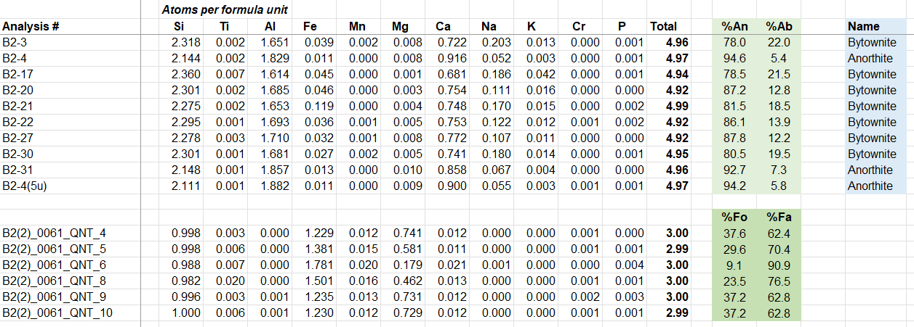

3.5. Using the figure below where the 4 main types of lunar lithologies are displayed, identify what type of rock hosts the plagioclase and olivine analysed.

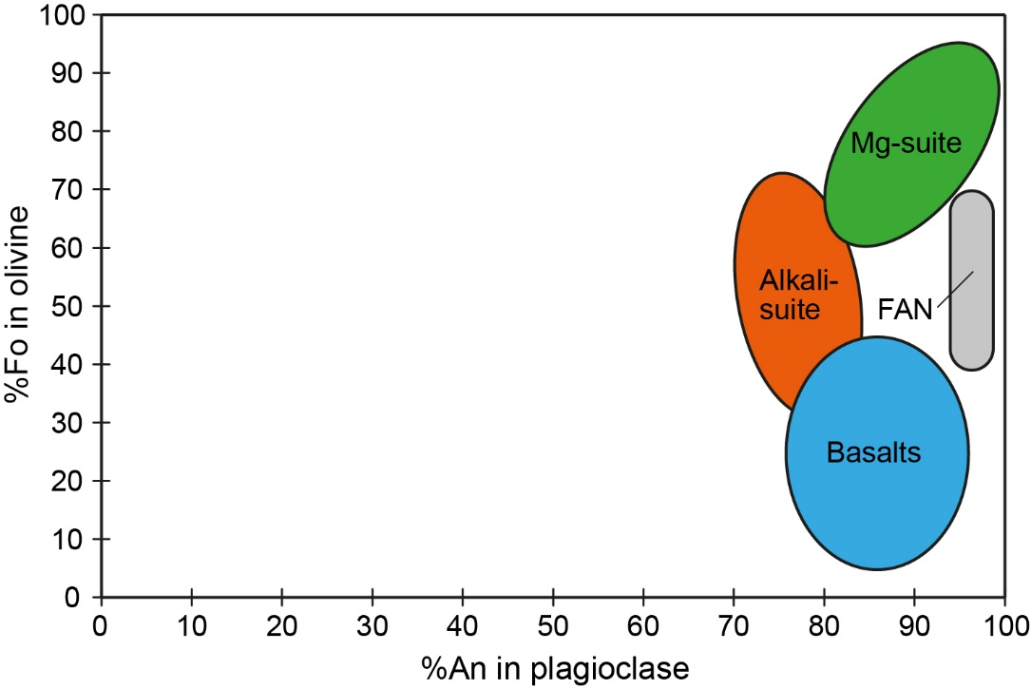

These plagioclase and olivine analyses are from a basalt sample.

